More on Supplier Database
Query 1: Find the most expensive part overall and the supplier who supplies it.
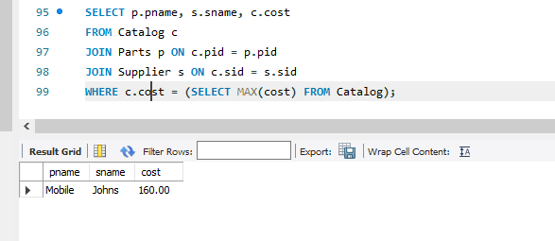
Query 2: Find suppliers who do NOT supply any red parts.
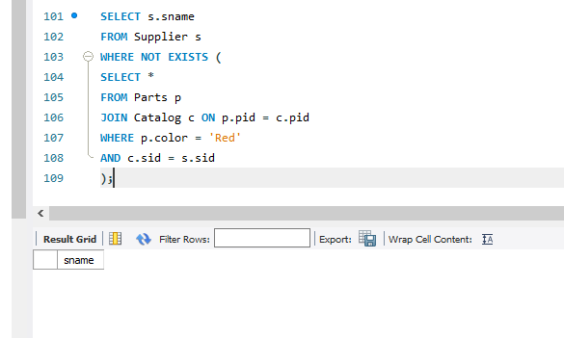
Query 3: Show each supplier and total value of all parts they supply.
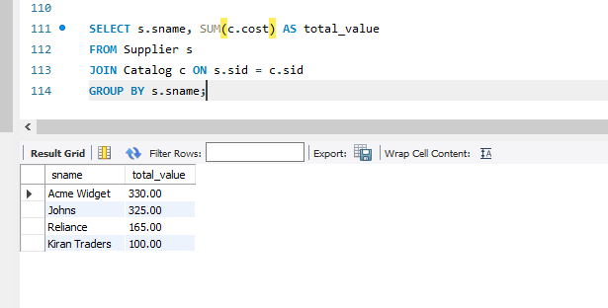
Query 4: Find suppliers who supply at least 2 parts cheaper than ₹20.
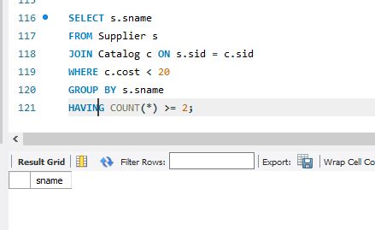
Query 5: List suppliers who offer the cheapest cost for each part.
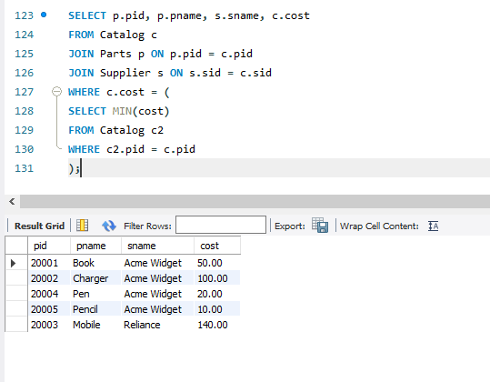
Query 6: Create a view showing suppliers and the total number of parts they supply.
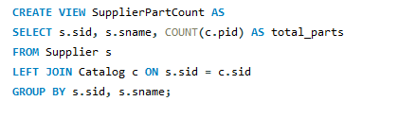
Query 7: Create a view of the most expensive supplier for each part.
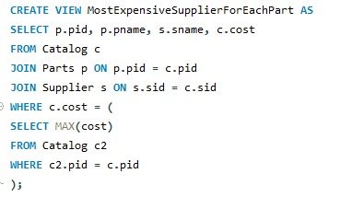
Query 8: Create a Trigger to prevent inserting a Catalog cost below 1.
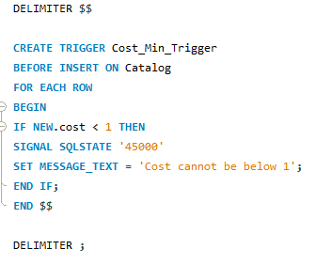

Query 9: Create a trigger to set to default cost if not provided.
